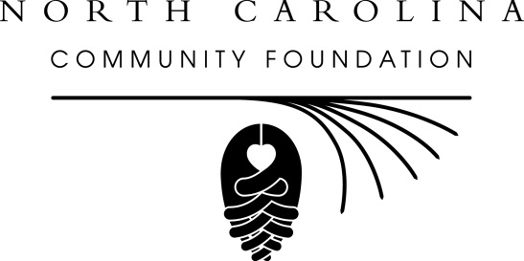
NCCF announces two new statewide board members
For immediate release – Feb. 14, 2014
Juan Austin and Katharine Harrison Hardin have been appointed to the statewide board of directors of the North Carolina Community Foundation (NCCF), according to Stuart B. Dorsett, chairman of the board.
Austin is senior vice president for the Wells Fargo Foundation for North Carolina and South Carolina. The Greensboro native lives in Jamestown. He is a member of the board of the NC Business Committee for Education and a former board member of the NC Center for Nonprofits and the NC Public School Forum. He is a graduate of Campbell University with a bachelor’s degree in trust management.
Hardin is office administrator for James C. Hardin III, PLLC, a law firm that specializes in estate planning. The Rocky Mount native lives in Rock Hill, SC. She is an active volunteer and has been involved as a board member for Saint Mary’s School in Raleigh, the YMCA, the Junior League of Washington DC and Charlotte and Children’s Hospital. She is a graduate of Saint Mary’s Junior College and the University of North Carolina at Chapel Hill.
Dorsett said the NCCF was fortunate to have leaders the caliber of Austin and Hardin serve on the statewide board. “Their professional experience and community leadership will serve the Foundation well,” he said.
About NCCF
The NCCF is the single statewide community foundation serving North Carolina and has made nearly $74 million in grants since its inception in 1988. With more than
More
$171 million in assets, NCCF sustains 1,200 endowments established to provide long-term support of a broad range of community needs, nonprofit organizations, institutions and scholarships. The NCCF partners with 60 affiliate foundations to provide local resource allocation and community assistance in 67 counties across the state. An important component of NCCF’s mission is to ensure that rural philanthropy has a voice at local, regional and national levels. For more information, visit www.nccommunityfoundation.org and Facebook or follow on Twitter@NCCF.
END
NEWS MEDIA CONTACT:
Noel McLaughlin
NCCF Director, Marketing and Communications
(919) 256-6901
nmclaughlin@nccommunityfoundation.org

For Campbell University alumni news: Juan Austin is a 1986 graduate
For UNC-Chapel Hill alumni news: Katharine Harrison Hardin is a 1972 graduate

